CSA1708-ARTIFICIAL INTELLIGENCE
LAB EXPERIMENTS
Program 30 : Prolog Program for Backward Chaining
Aim
To prove a query by working backward from its goal to known facts.
Algorithm
1. Start with a query goal.
2. Check whether the goal is a stored fact.
3. Match a rule and recursively prove its conditions.
4. Succeed if all conditions are proven; otherwise fail.
Program
fact(rain).
rule(wet_grass, [rain]).
rule(slippery_road, [wet_grass]).
backward_chain(Goal) :-
fact(Goal).
backward_chain(Goal) :-
rule(Goal, Conditions),
prove_all(Conditions).
prove_all([]).
prove_all([Goal|Rest]) :-
backward_chain(Goal),
prove_all(Rest).
Sample Input
?- backward_chain(slippery_road).
?- backward_chain(flooded_street).
Program Execution
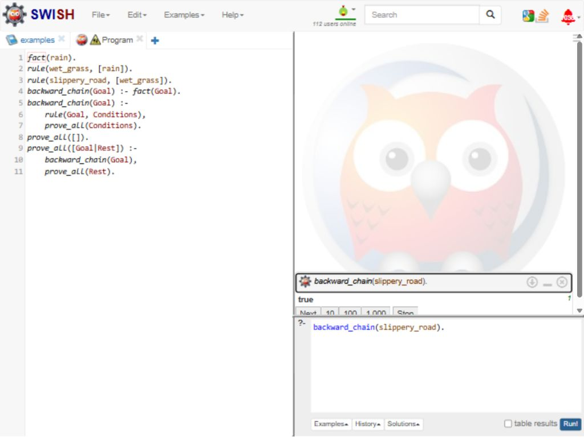
RESULT
Thus, backward chaining proved slippery_road; flooded_street failed.

